INTERNATIONAL POLYAMINE CONFERENCE 2026

- FROM PHYSIOLOGY TO DISEASE -

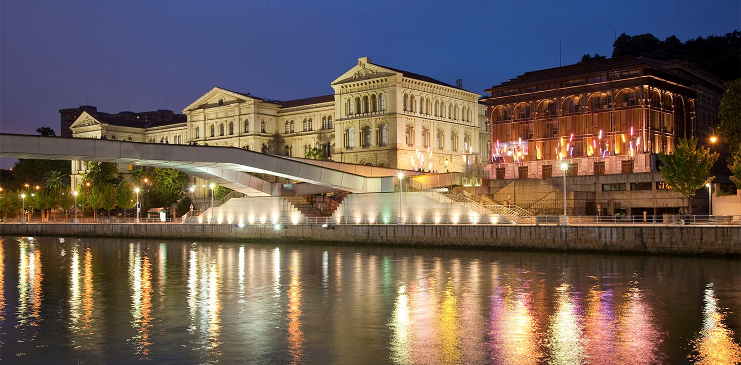
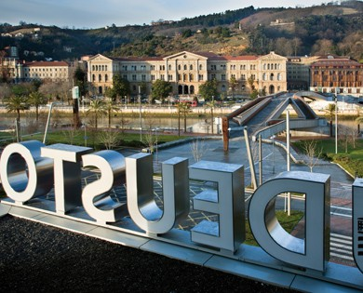

SEPTEMBER 23 – 25, 2026 | UNIVERSIDAD DE DEUSTO BILBAO, SPAIN

Welcome
We are pleased to welcome you to the biennial International Polyamine Conference (IPC), hosted at the Universidad de Deusto in Bilbao (Spain), from Wednesday 23rd to Friday 25th September 2026.

Scientific Program Committee
Amaia Zabala (CICbioGUNE, Spain) Arkaitz Carracedo (CICbioGUNE, Spain) Enzo Agostinelli (Sapienza University, Italy)
Sigrid Roberts (Pacific University Oregon, USA) Stephan Sigrist (DZNE, Germany)
Otto Phanstiel (University of Central Florida, USA)

Confirmed speakers:
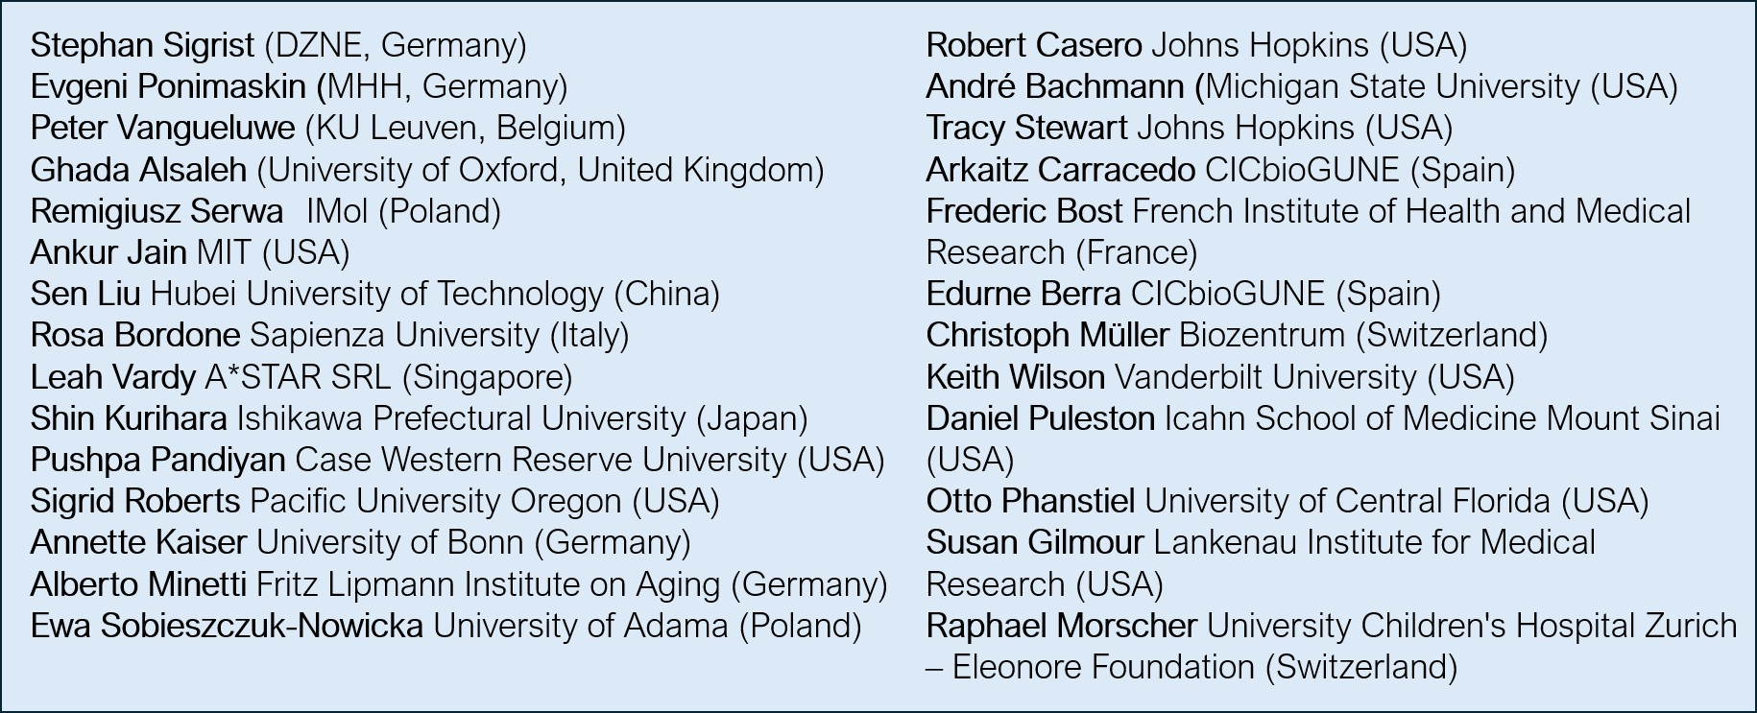

Stay tuned for program details and updates!



Conference Overview

Venue:
Universidad de Deusto
Avenida de las Universidades, 24 48007 – Bilbao, Spain

Conference Hours:
23rd September: 10:00 – 18:00
24th September: 09:00 – 18:00
25th September: 09:00 – 16:00
& Optional Tourism: 16:00 – 20:00

Important Dates
Abstract submission deadline: 31st May 2026 Registration deadline: 30th June 2026
Cancellation deadline (refund eligible): 15th August 2026

Registration Information
Registration is confirmed once we have received both your completed registration form and payment. A confirmation email will be sent by Kathrin Keim (polyamineconference@cicbiogune.es).

Click here to register for the Bilbao IPC:
International Polyamines Conference, Bilbao - Registration Form

Registration Fees:
  - Scientist: €300
  - Student: €175

Optional Social Dinners
Attendance at the dinners is optional and not included in the registration fee.
  - Conference Dinner (September 23rd): €50 per person
  - Polyamigos Dinner (September 24th): €50 per person
Please note that accompanying guests are welcome, but each guest attending a dinner must also pay the corresponding €50 dinner fee.

Payment Details:
Bilbao IPC Account
IBAN: ES28-2100-8686-8102-0006-0804
Beneficiary: ASOC CENTRO INVEST COOP BIOCIENCIAS CICBIOGUNE
Concept: INCLUDE LAST NAME OF THE APPLICANT

Cancellation Policy
In case of cancellation, the registration fee will be refunded excluding a €60 handling fee. A written request must be received before 15th August 2026. No refund will be made for cancellations received after this date. Substitutions are accepted at any time. Applicable refunds will be processed after the conference via bank transfer.

Abstract Submission
Please send your abstract by email to Amaia Zabala (polyamineconference@cicbiogune.es)

Accommodation in Bilbao
To make planning easier, a limited number of rooms have been reserved for conference participants and speakers at selected hotels in Bilbao, with a range of options to match different preferences.

See hotel list last page! >>>

Maps & contact
Interactive map: IPC 2026 - Conference Venue & Hotels

Tourism info video: https://youtu.be/WSuXnNeqAxw?si=SX055I3TKe5tVMLl
Questions? Contact the organizing committee: polyamineconference@cicbiogune.es

We look forward to seeing you in Bilbao!


NH Deusto Bilbao
2-MIN WALK TO VENUE; 10-15-MIN WALK TO CITY CENTER

Booking
Email: nhdeusto@nh-hotels.com
BOOKING CODE: “INTERNATIONAL POLYAMINE MEETING” MORE INFO: HTTPS://WWW.NH-HOTELS.COM/EN/HOTEL/NH-BILBAO-DEUSTO







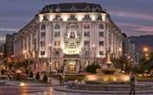



Hotel ILUNION Bilbao
18-MIN WALK OR 15 MIN BY TRAM TO VENUE; IN THE CITY CENTER

Booking
Link: https://www.ilunionhotels.com/en/colectivos/cicbio26
BOOKING Code: CICBIO26 More info: https://www.ilunionhotels.com/hoteles/ilunion-bilbao

Hotel Carlton
18-MIN WALK OR 11 MIN BY BUS TO VENUE; IN THE CITY CENTER

Booking
Booking link: www.hotelcarlton.es – Booking Code: CIC2026
BOOKING BY EMAIL: carlton@aranzazu-hoteles.com - REF: GRHA3260
More info: www.hotelcarlton.com

Hotel Abando
25-MIN WALK OR 15 MIN BY TRAM TO VENUE; IN THE CITY CENTER

Booking
Booking link: www.hotelabando.com – Booking Code: CIC2026
BOOKING BY EMAIL: abando@aranzazu-hoteles.com - REF: GRHA3258
More info: www.hotelabando.com

